Giadinhtiendung e-commerce website

UI Prototype

Version 0.1

Revision History

| **Date** | **Version** | **Description** | **Author** |
| --- | --- | --- | --- |
| 16/12/2023 | 0.1 | Initial writings, prepare format and give out direction | Lê Quang Trường |
| 16/12/2023 | 0.1 | Add description for each UI page | Nguyễn Gia Khánh |
| 16/12/2023 | 0.1 | Design UI elements | Nguyễn Văn Tuấn Kiệt |
| 16/12/2023 | 0.1 | Add descriptions, add images. | Bùi Nguyên Hanh |
| 16/12/2023 | 0.1 | Organize and formalize the document, draw logical diagram of the UI | Trần Ngọc Trường Thịnh |

UI Prototype

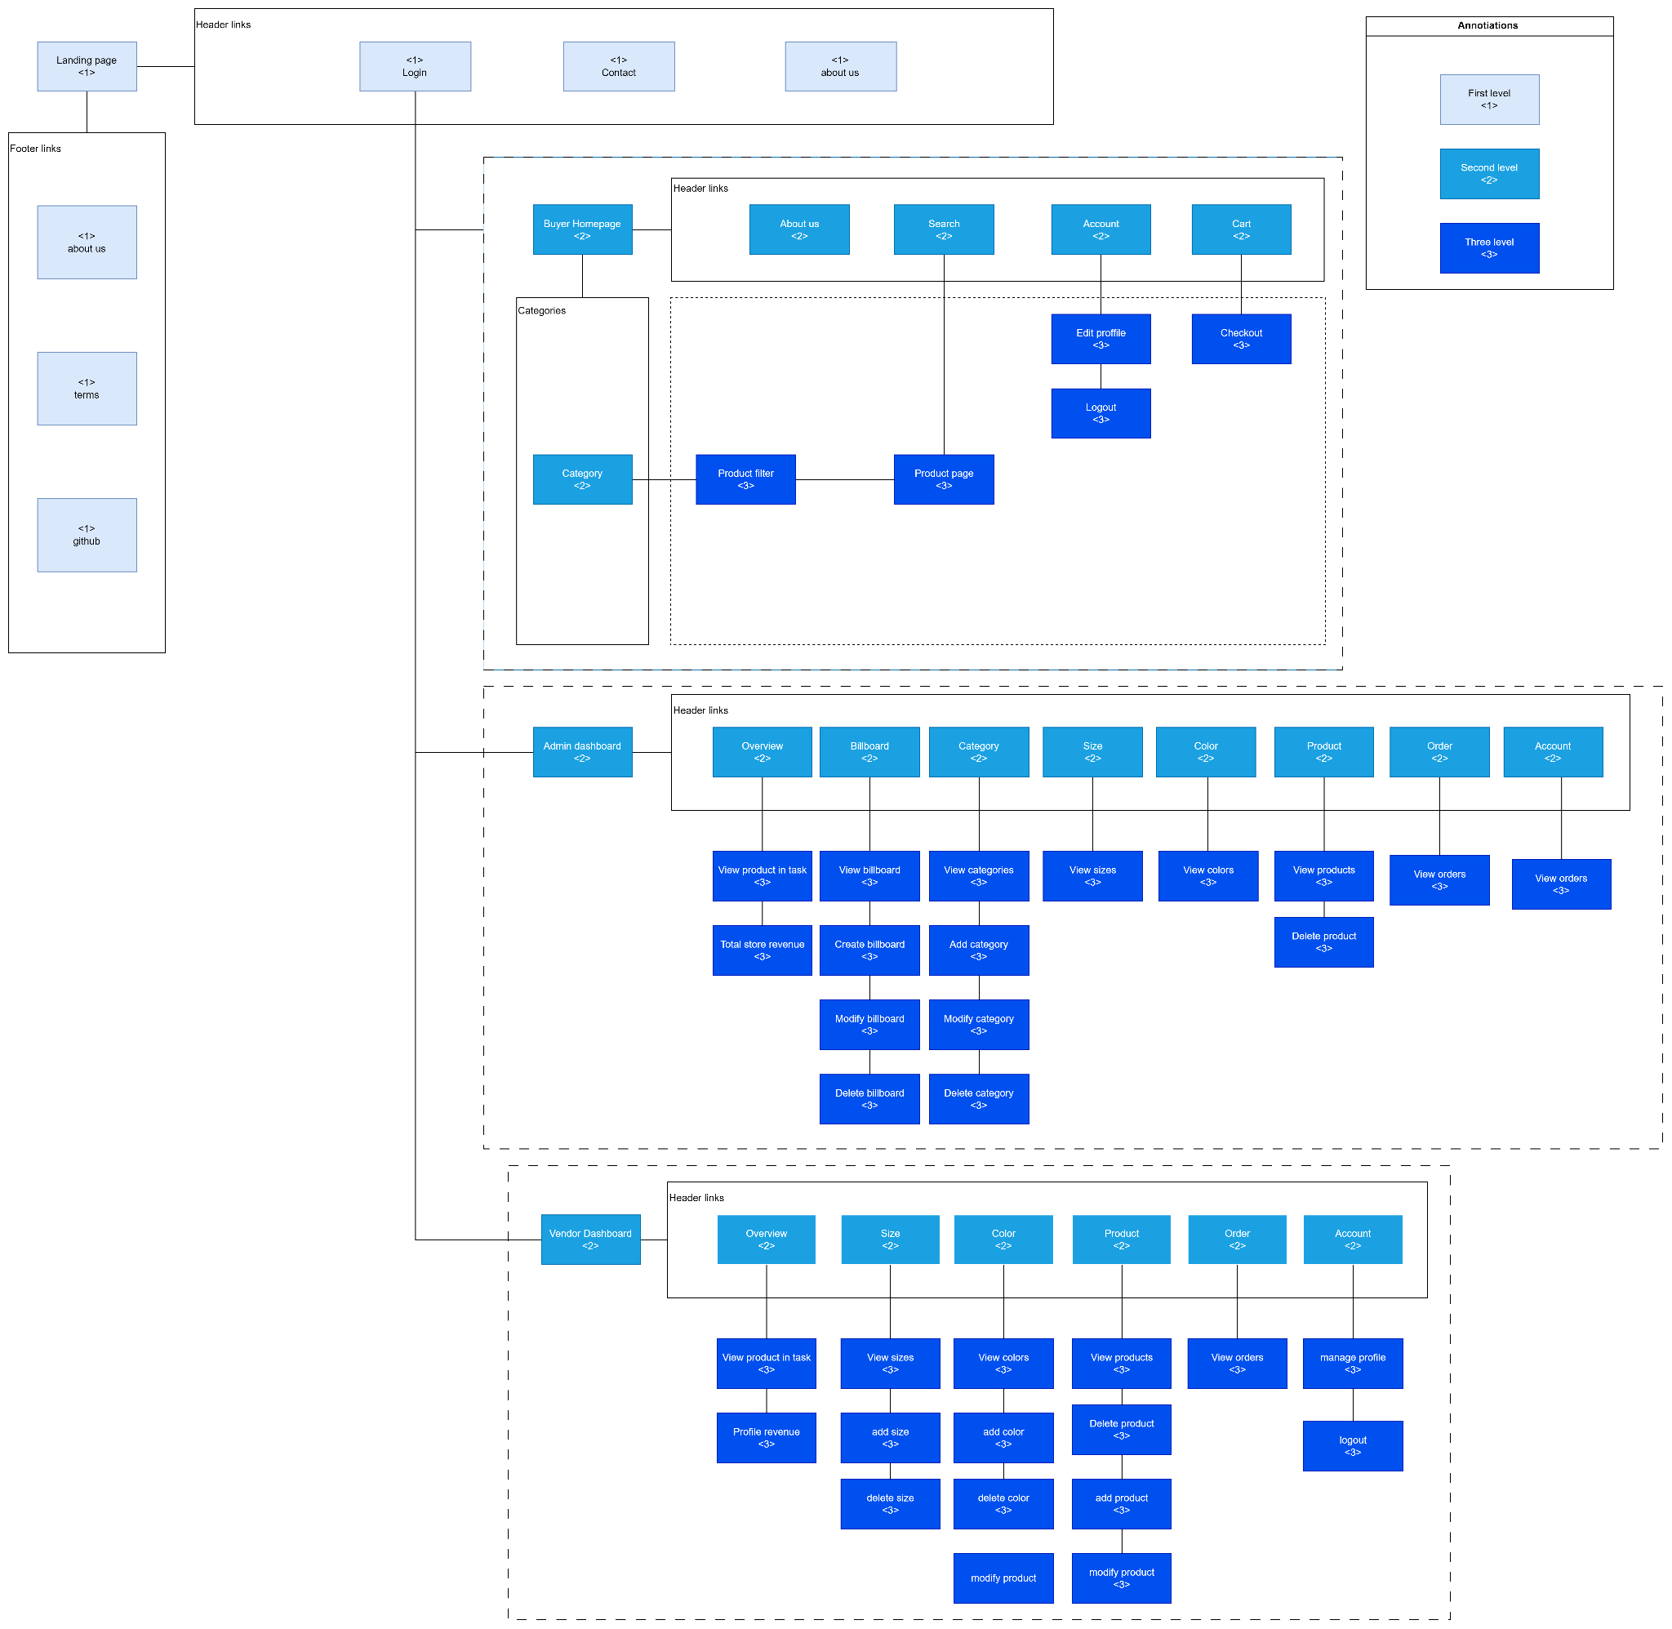

Link diagram: <https://drive.google.com/file/d/1Aa6E8V5cfrC5Jom8b2bO3Ip3LTOjwspT/view?usp=sharing>

1. Landing page:

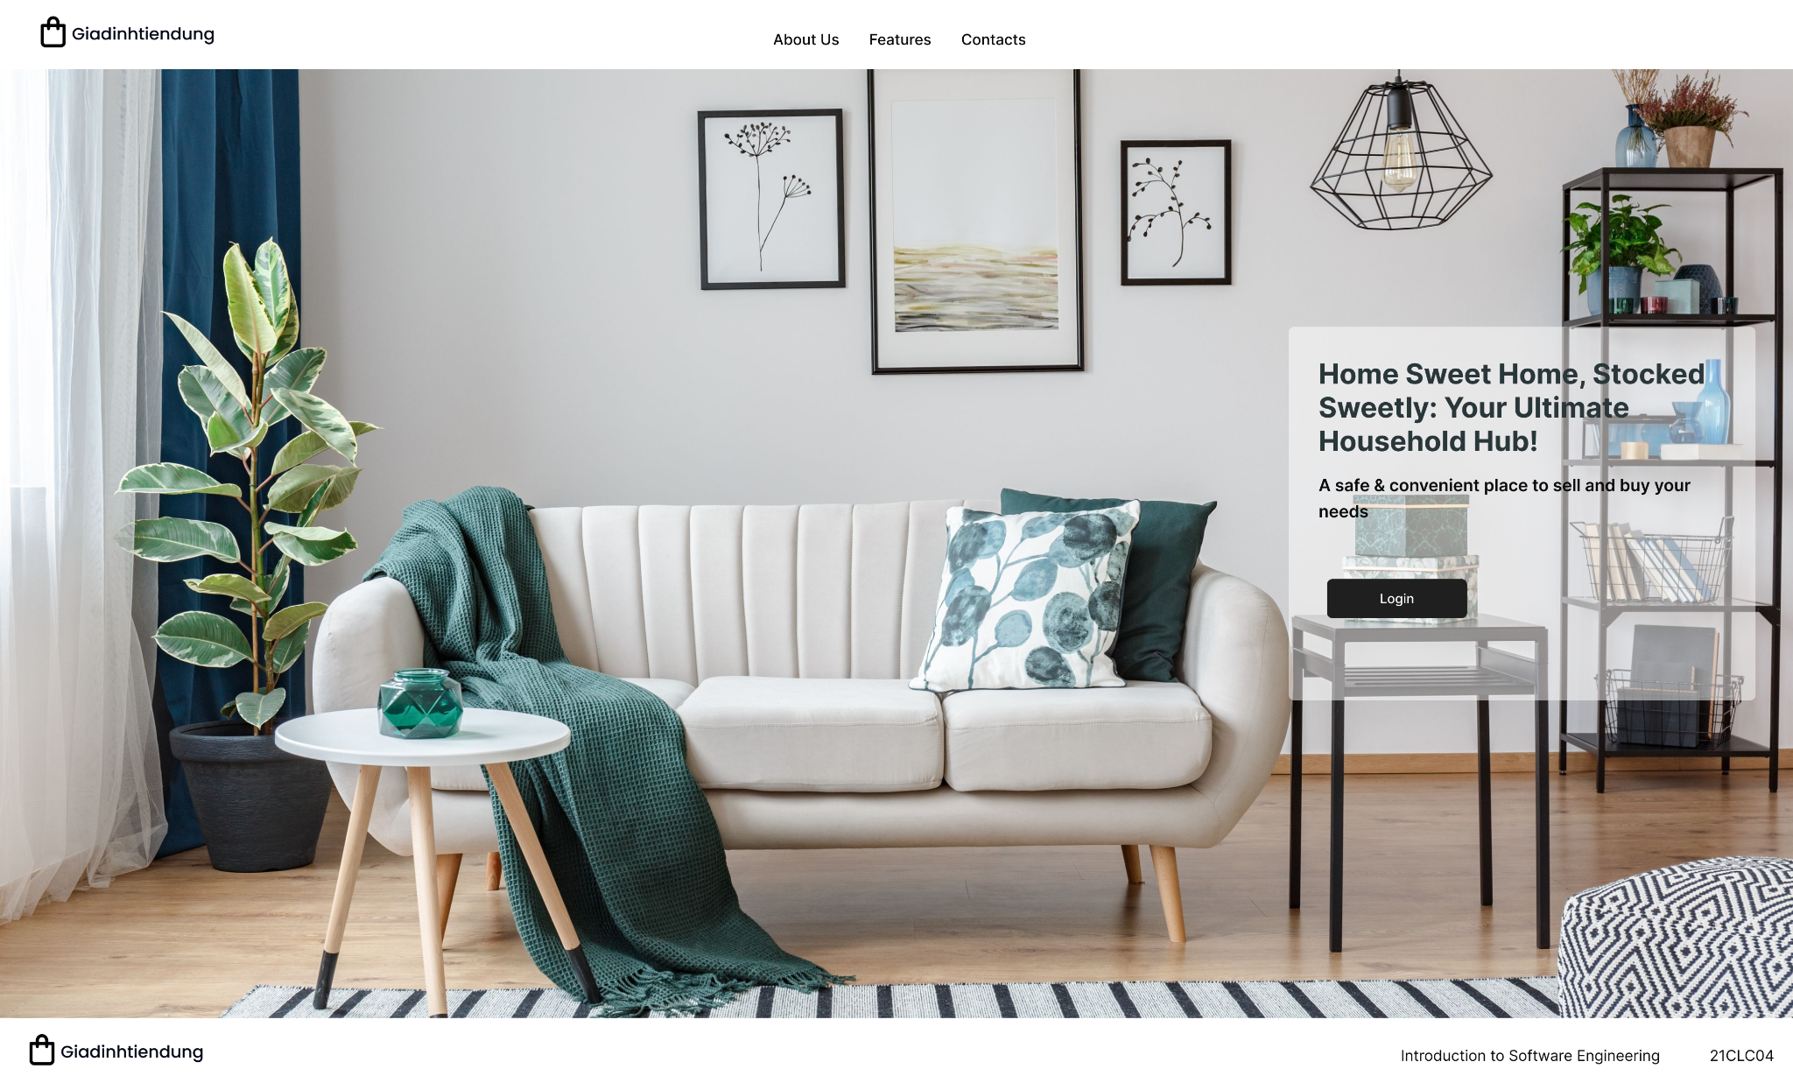

**Purpose:** This screen is for authentication purposes, shows when a user lands at the website.

**How to use:** Click on login button to proceed to the authentication service provider.

**User:** All user

1. Sign up page:

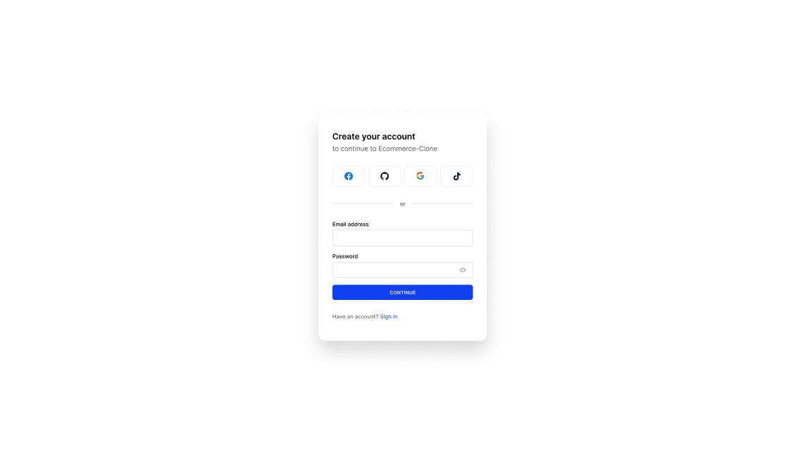

**Purpose:** Create an account for a user

**How to use:** Fill all the information in the “Email address” blank and “Password” blank or click on social media icons to use that account to sign up.

**User:** Vendors, Buyers

1. Sign in:

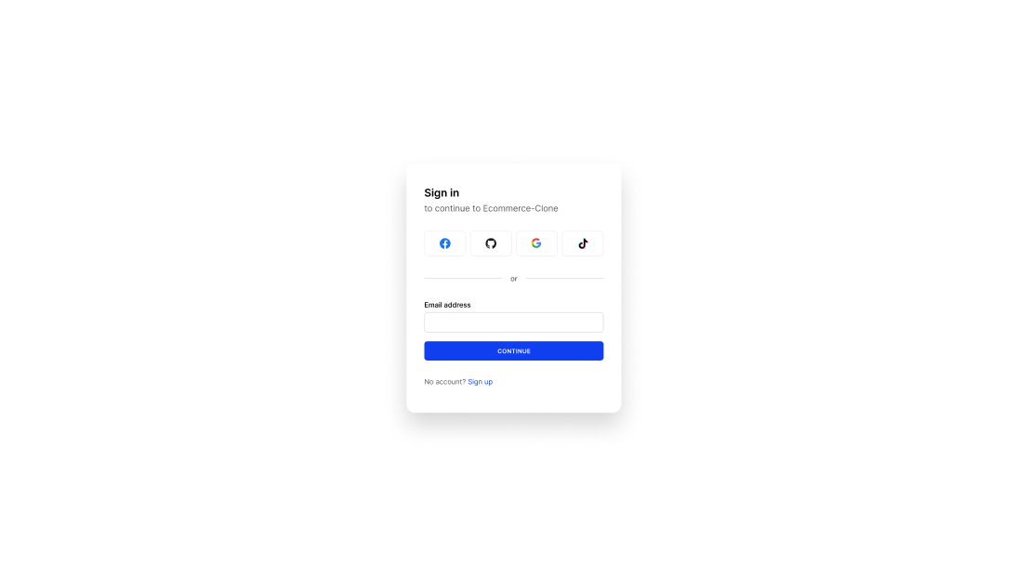

**Purpose:** Sign in

**How to use:** Fill all the information in the “Email address” blank and “Password” blank or click on social media icons to use that account to sign up.

**User:** All users

1. Home page:

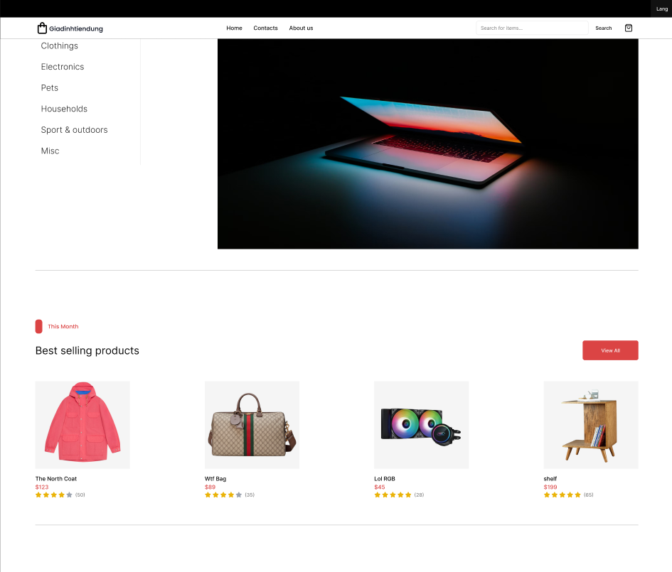

**Purpose:** the first thing people see when they are coming to a website. So it absolutely plays a crucial role in engaging them so that they can keep interested in products.

**How to use:**

* If buyers want to view any products interested them, they just need to click on the image of products
* There are many categories of products for them to choose which one they like to buy

**User:** All users

1. Product page:

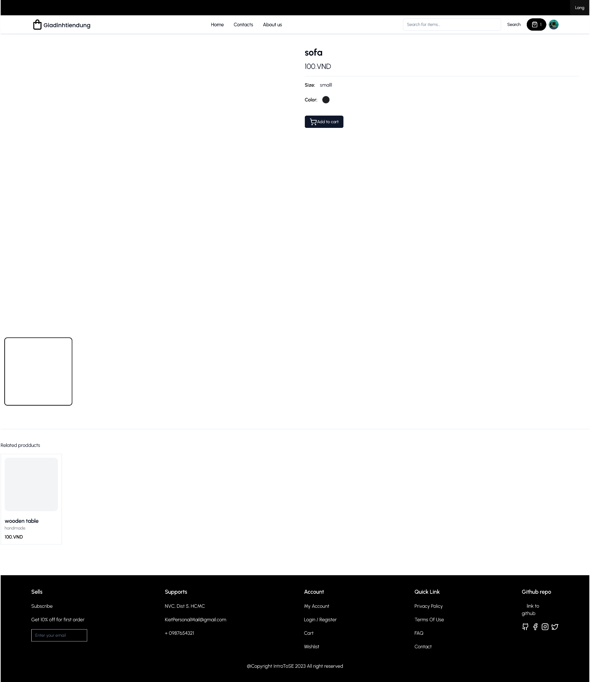

**Purpose:** Show detailed information about a product, and suggest some related products.

**How to use:** User can click add to cart to add this product to their cart. From here user can also click on cart button next to their profile avatar to open their cart management.

**User:** Buyers

1. contact page:

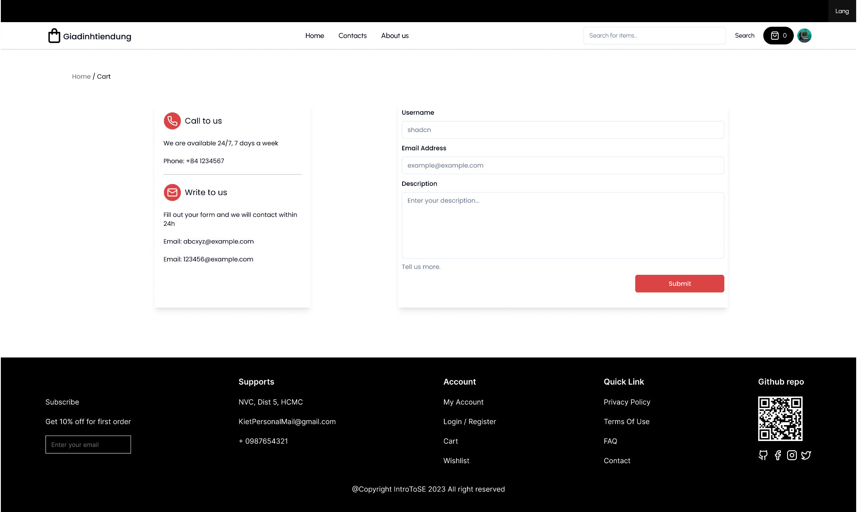

**Purpose:** Public some of our information, so any customer can contact us if they need to.

**How to use:** Fill all the information in the “Email address” blank and “Password” blank or click on social media icons to use that account to sign up

**User:** Everyone

1. Cart

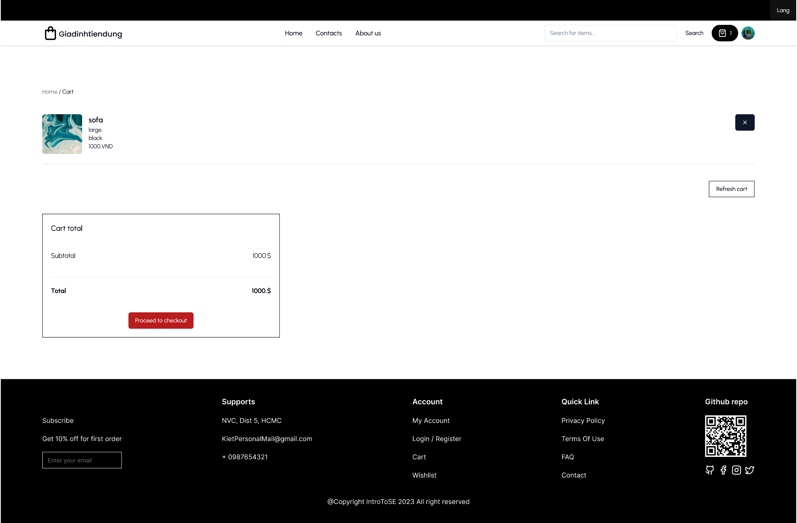

**Purpose:** To show all the product that they have added before, and count the total price

**How to use:** Click on cart, then it will show all the information that i have just mentioned already.

**User:** Buyers

1. Category search page

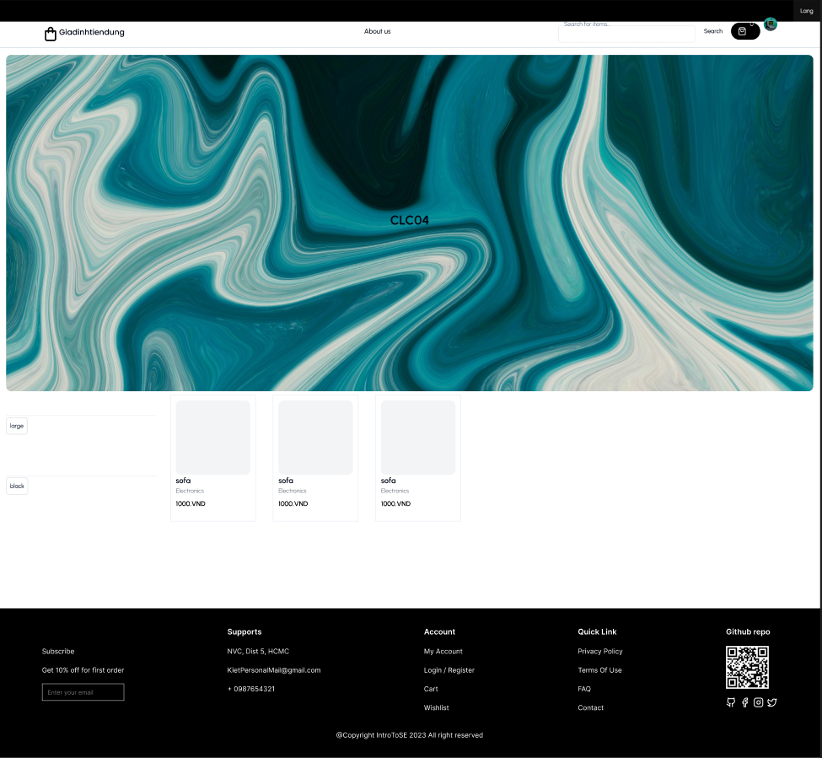

**Purpose:** Let user search products using provided category and color

**How to use:** Users may click some of the buttons on the left to apply a filter on the list of displayed products. Meanwhile user can click on a product to see its product page

**User:** Buyers

1. Stripe checkout

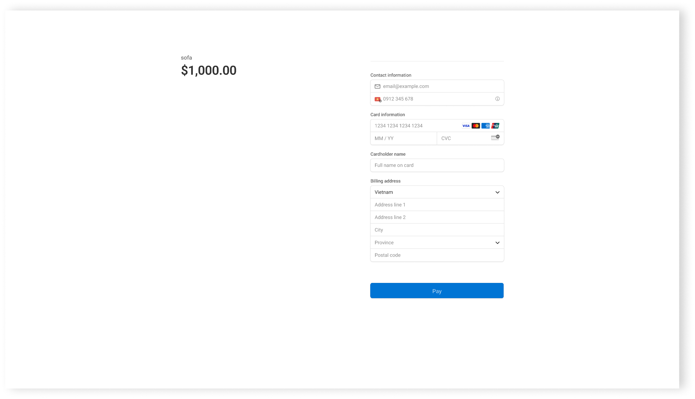

**Purpose:** Calculate the total amount the user needs to pay and how the user can pay the amount

**How to use:** Total price will show itself automatically, but in checkout part you must fill all information into these blanks

**User:** Buyers

1. Admin billboard management

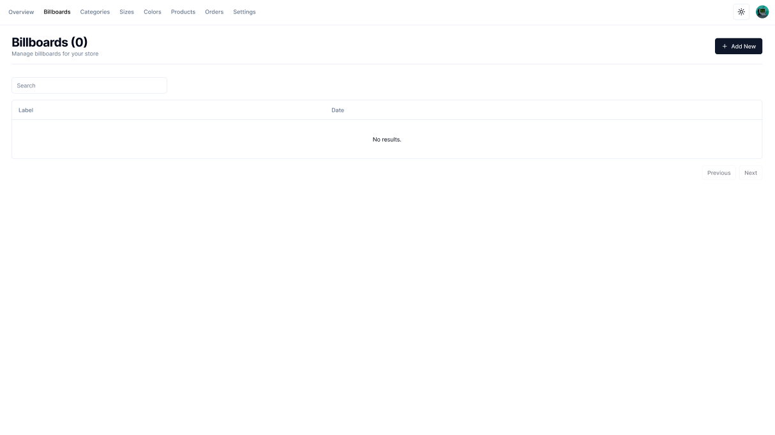

**Purpose:** Control billboards that will be used to play advertisements

**How to use:** The admin can use the “+ Add New'' button to add a new billboard.

The table in the middle of the page will be used to display billboards that are currently in use and also for deleting billboards.

The search bar above the table is used for searching a billboard.

**User:** Admin

1. Admin category management

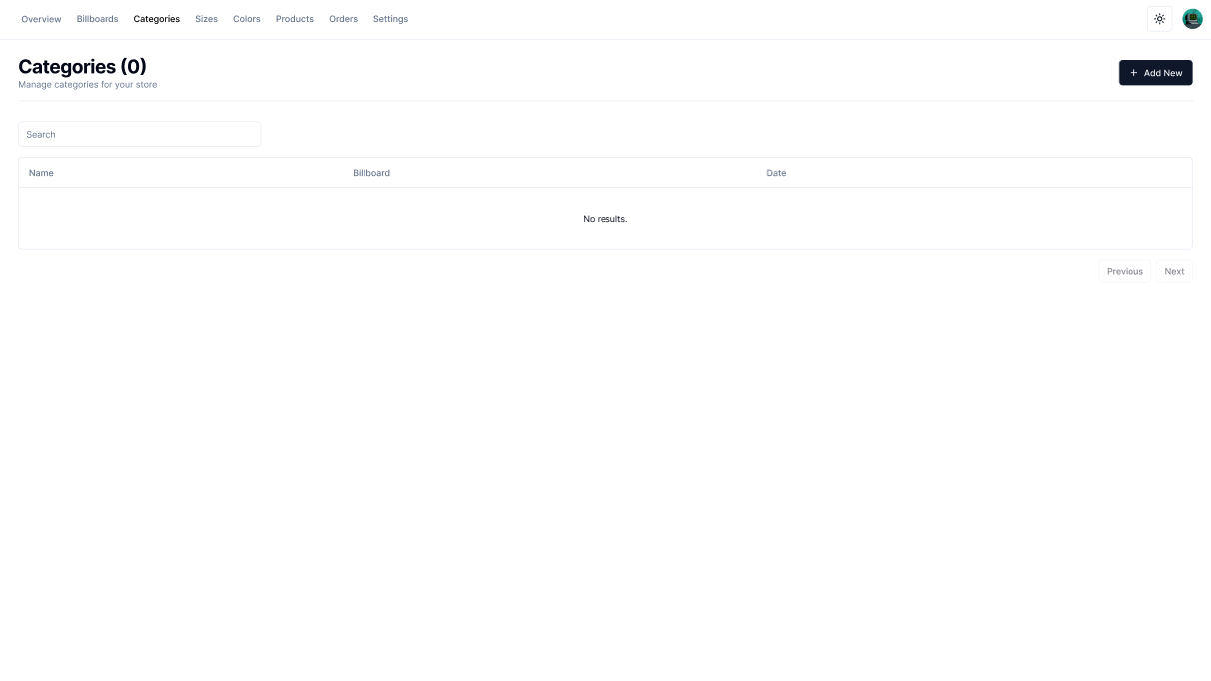

**Purpose:** Let admin see and add categories of product to the database

**How to use:** A list of categories will be displayed in the list box, admins can type on the search box to specify what they are looking for. Admins can click on “+ Add new” button to create a new category.

**User:** Admins

1. Vendors/Admins dashboard

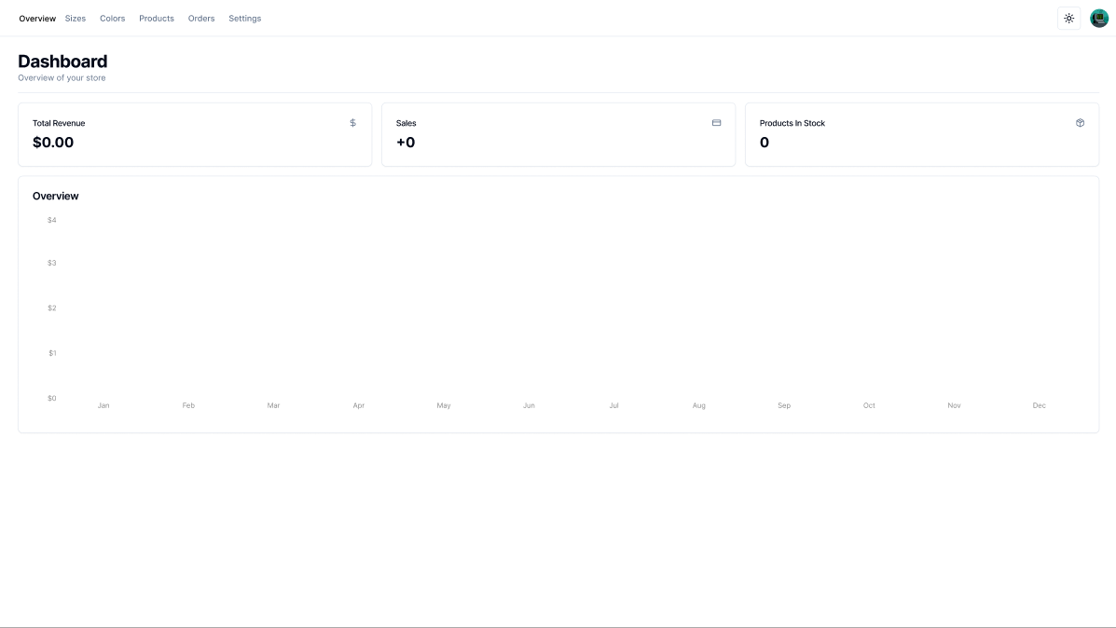

**Purpose:** Adashboard is where vendors and admin can access and manage their operations within the marketplace platform.

**How to use:** A vendor dashboard includes information about total revenue, Sales, product in Stock, and over View. Vendors can base this to keep track of their business.Vendors can see their own statistics while admin can see the statistics of the whole platform.

**User:** Vendors, Admins

1. Vendor add product form

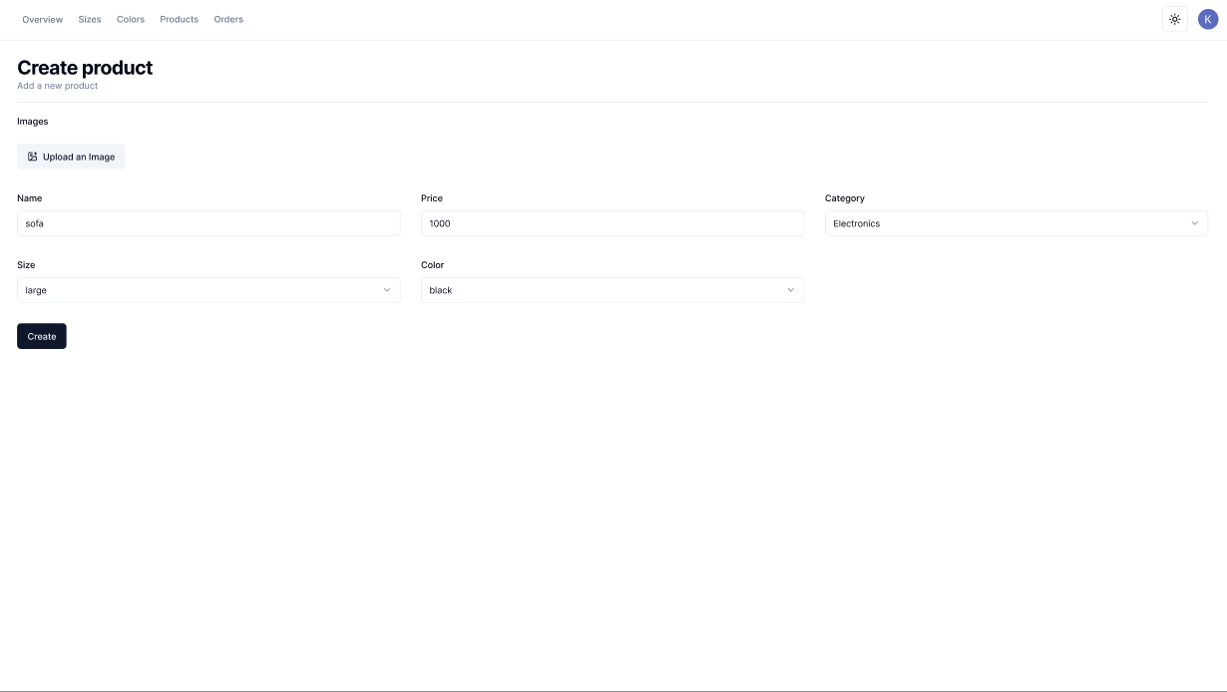

**Purpose:** Create a new product to the store.

**How to use:** Vendor will choose all the features that must be added and information for that product, and then click on the “Create” button to create a new product to the store.

**User:** Vendors

1. Vendor add color form

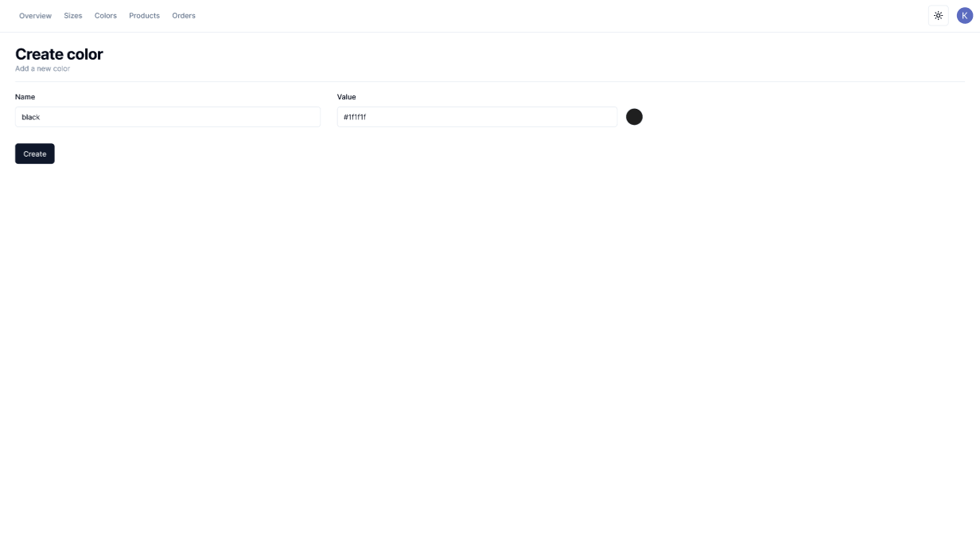

**Purpose:** Let vendor create a new color for their products

**How to use:** Vendors fill Name box and Value box, their will be a color picker on the right of the Value box

**User:** Vendors

1. Vendor add size form

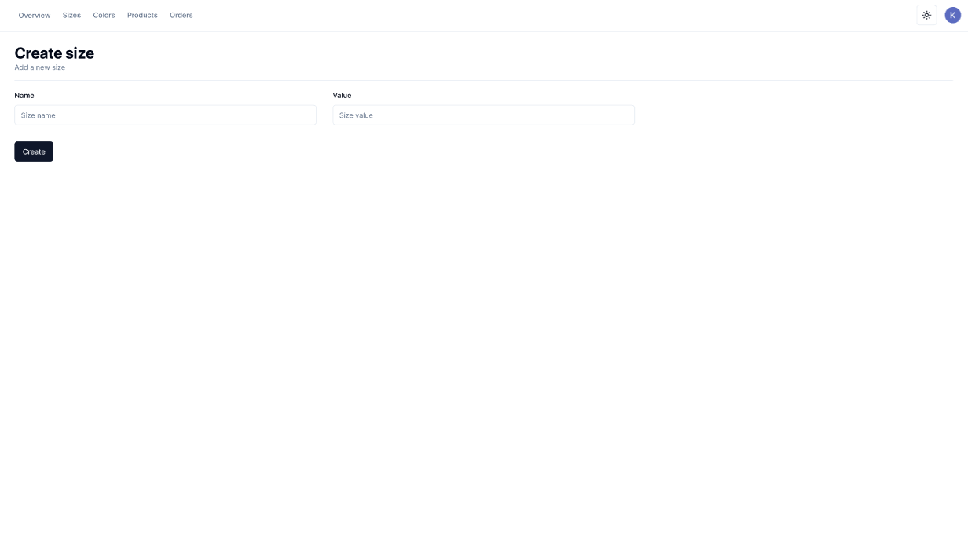

**Purpose:** Tool for the vendor to create a new size for a product

**How to use:** The “Name” text box is for entering the name of the new size. The “Value” text box is for entering size value.

**User:** Vendors

1. Vendor product management

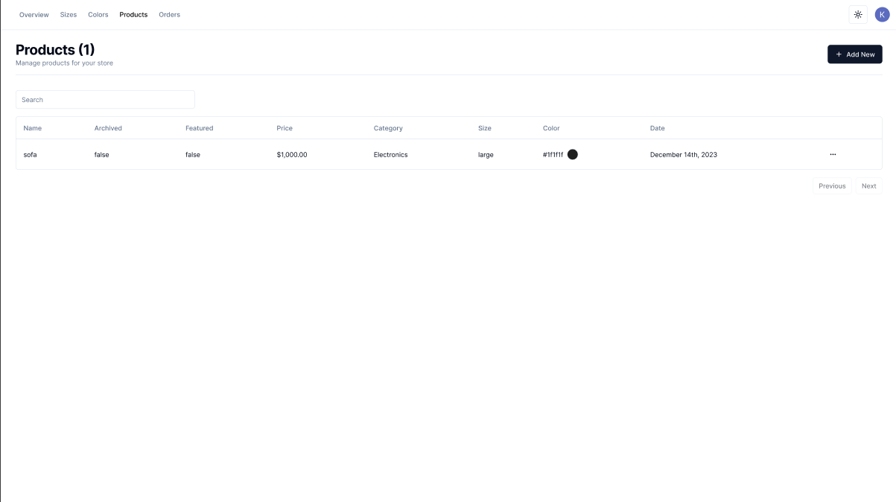

**Purpose:** Management tools for the vendor’s products

**How to use:** The list box in the middle of the page is used to display the products currently available on the vendor’s store. It can also be used to edit a product information or delete a product from the store.

The “+Add New” button is for adding new products to the vendor’s store.

The search bar on the top of the list box is used to search for products that is in the list box.

**User:** Vendors

1. Buyer/Vendor order management

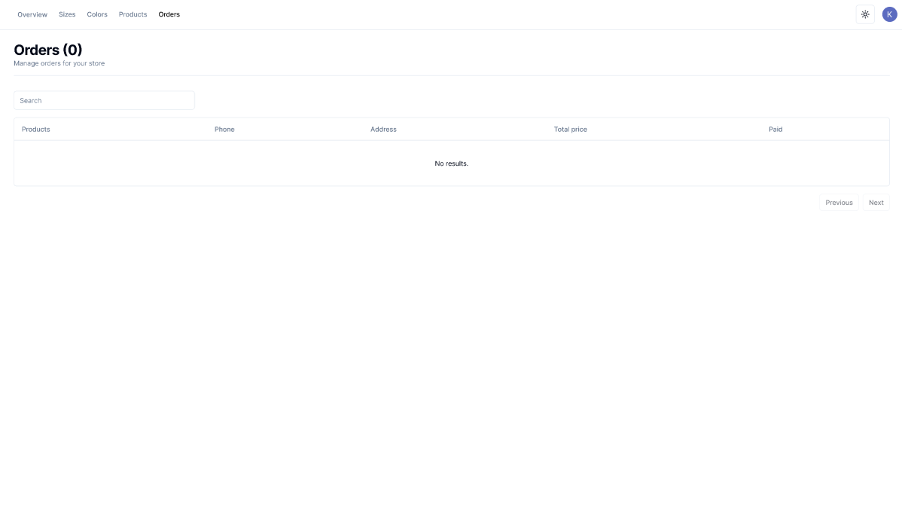

**Purpose:** Let user see their orders

**How to use:** User may click on an item in the list box, which holds orders of the user, to see more detail

**User:** Vendors, Buyer

1. Vendor size management

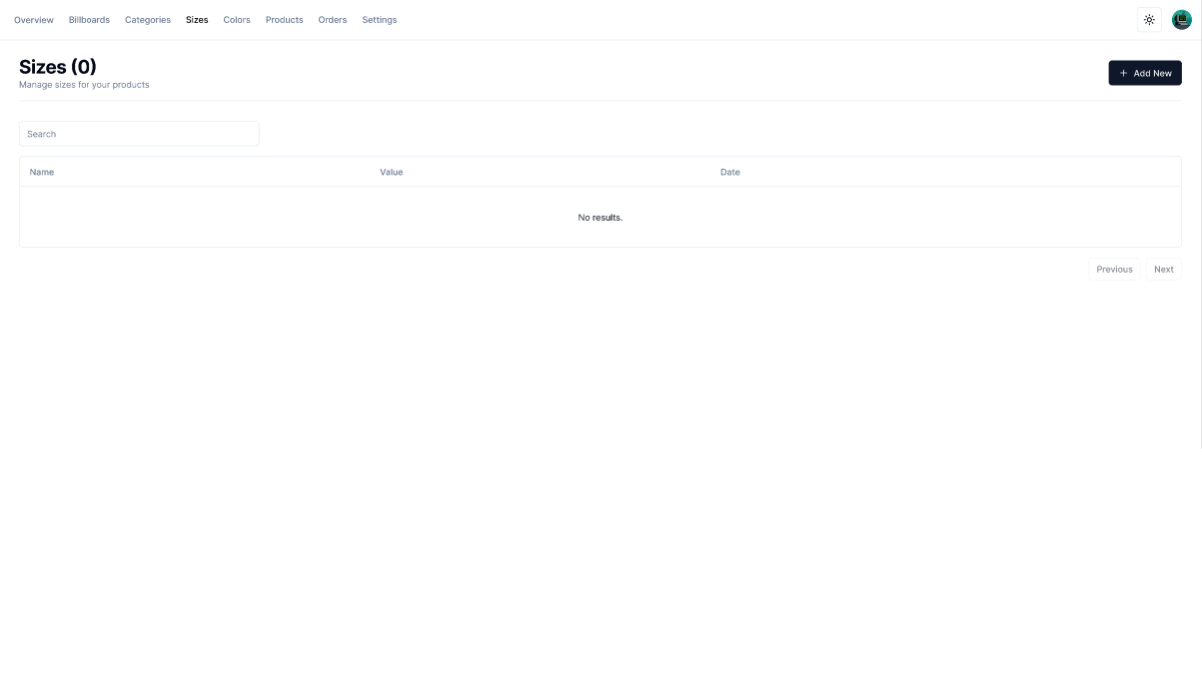

**Purpose:** Management tools for a product sizes

**How to use:** The list box in the middle of the page is used to display the sizes currently available for a product. It can also be used to edit the sizes of a product or delete it.

The “+Add New” button is for adding new sizes to a product.

The search bar on the top of the list box is used to search for sizes that are currently available for a vendor’s products.

**User:** Vendors